**Eila**

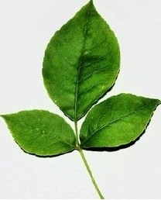

Eco friend ly Pencil